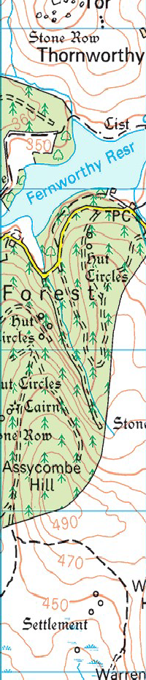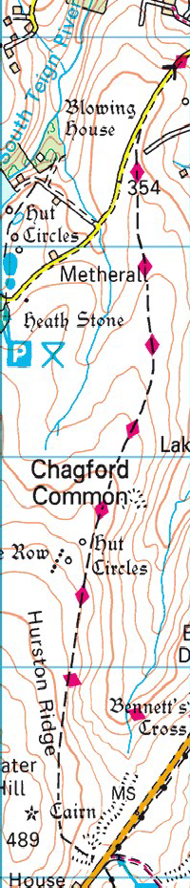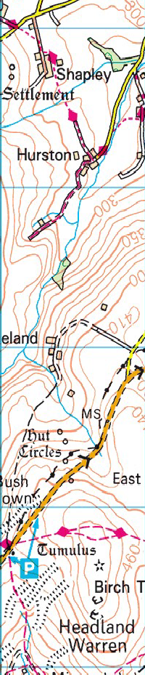

We can park on the grass verge as marked by the arrow. Then we’ll follow the 2 Moors Way until we reach the long stone row then turning West and walking back through Fernworthy Forest and following the road by the reservoir back to the cars. For those who prefer a slightly shorter walk we can return from the Stone Row via a track on the edge of where the moorland meets the forest, joining the road a little sooner.

