19 April 2017 Evening Walk
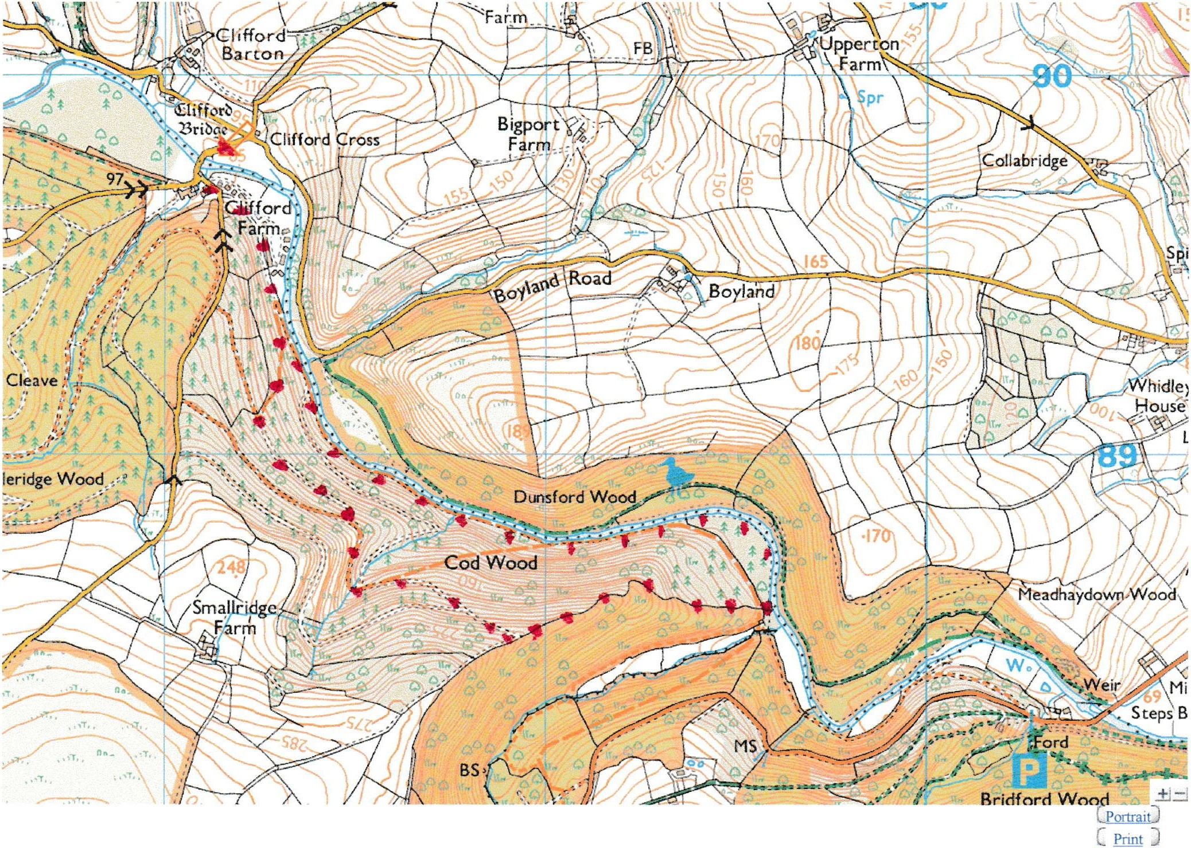
All Technolo gy © Copyright: Streetmap .co.uk/S treetmap EU Ltd 2016
This site includes mapping data l icenced from Open Street Map, Ordnance Survey & Bartholomew.

We will park near Clifford Bridge and take the track downstream on the South side [see red dots on map above]. Just after the track comes close to the river we will go uphill to the right, initially through beech woods, and then following various tracks up to the highest point. Once there, and after a breather !!, we follow a path down the ridge in Cod Wood to Ross Meadow at the bottom. We’ll then follow the river back up to Clifford Bridge.

Those who want a less strenuous walk can take the track by the river down to the Meadow and return the same way.

At the end of the walk those that want to could go to The Royal Oak at Dunsford for a drink / supper! Or, alternatively, The Old Thatch in Cheriton.

