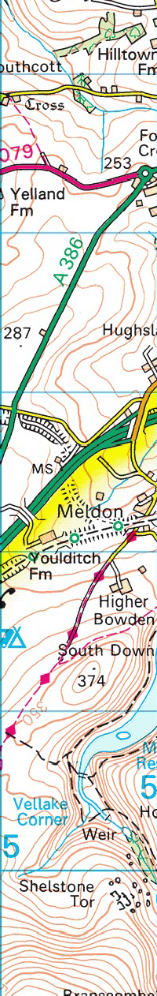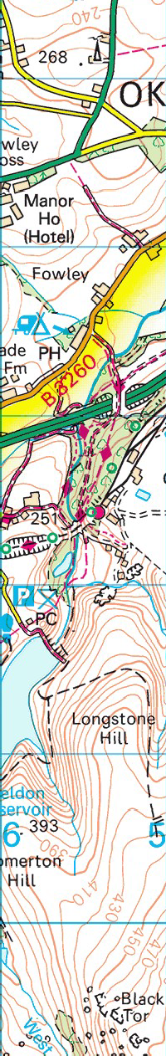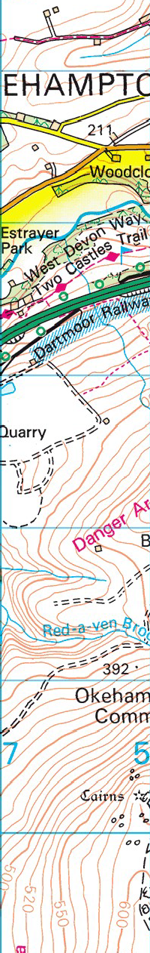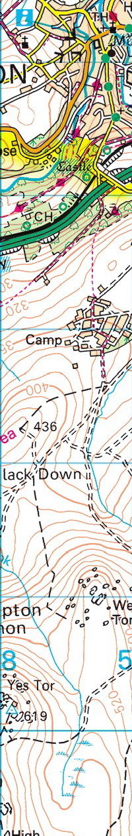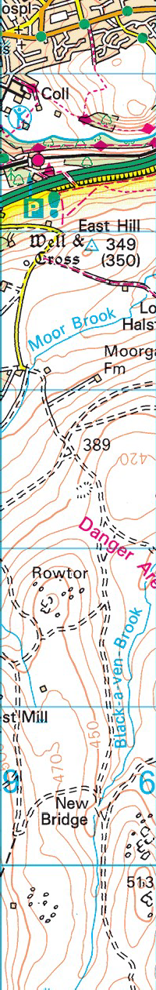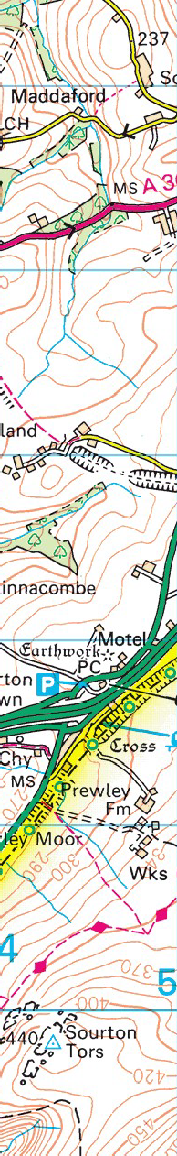Streetmap.co.uk- search results for 258278,92758 http://www.streetmap.co.uk/idld.srf?x=258278&y=9275

17th September 2017 Okehampton Station walk

Starting at Okehampton Station leave by the main gate, cross the road, walk along the private road that runs parallel to the Granite Way, cross Tors Road [that leads uphill to Oke Camp], enter footpath via wooden gate. Follow footpath (West Devon Way) to the West across the Golf Course. Anyone that wants to do the short walk can take a left in field and follow footpath up onto Granite Way then keep left and walk back to the station.
Those that want to continue, keep following the West Devon Way, [crossing the A30 at some point] until you reach the valley below Meldon Dam. Walk under the viaduct and from there you can either take the steep path/steps up to the top of the viaduct, or walk over the road for a short detour to see the flooded quarry lake on the other side of the river accessed by a footbridge 5 mins upstream from the road [cross footbridge and turn right to see this]. Return to the viaduct and take the steps up to the top where you will find the Buffet Car which may or may not be open. Then walk back along the Granite Way to Okehampton Station.

I think this is going to be at least 4 miles, probably more.

